

NAME: BISMA FATIMA
CLASS: CS A
ROLL NO: F24605036
COURSE: ARTIFICIAL INTELLIGENCE
COURSE CODE: CS-281
LECTURER: SIR IJLAL HAIDER

LAB 07

In Lab Tasks

Task 1
Given the graph, where A is the root node and each other node is either an internal node with children or a leaf node with a numerical value. The goal is to use the Minimax algorithm to determine the minimax score for each node, starting from the root and evaluating each intermediate node based on whether it maximizes or minimizes the score. Print the Minimax values for all nodes in the game tree, showing the optimal score that each node can achieve.
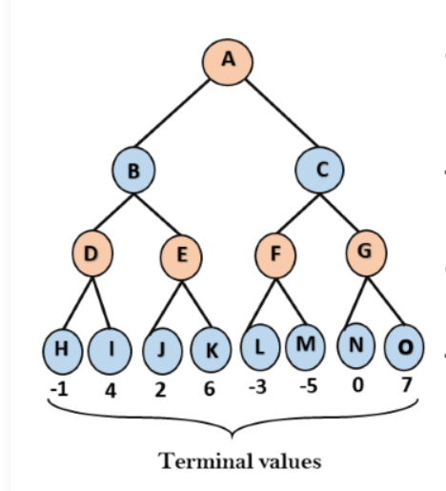
PROGRAM
# Define the game tree as a dictionary
game_tree = {
'A': ['B', 'C'],
'B': ['D', 'E'],
'C': ['F', 'G'],
'D': ['H', 'I'],
'E': ['J', 'K'],
'F': ['L', 'M'],
'G': ['N', 'O'],
'H': -1,
'I': 4,
'J': 2,
'K': 6,
'L': -3,
'M': -5,
'N': 0,
'O': 7
}

# Minimax function
def minimax(node, is_maximizing):
if isinstance(game_tree[node], int):
return game_tree[node]

children = game_tree[node]
scores = [minimax(child, not is_maximizing) for child in children]

return max(scores) if is_maximizing else min(scores)

# Compute minimax values for all nodes
minimax_values = {}

def compute_all_minimax(node, is_maximizing):
if isinstance(game_tree[node], int):
minimax_values[node] = game_tree[node]
return game_tree[node]

children = game_tree[node]
scores = [compute_all_minimax(child, not is_maximizing) for child in children]
value = max(scores) if is_maximizing else min(scores)
minimax_values[node] = value
return value

# Start from the root node 'A'
compute_all_minimax('A', False)

# Print the minimax values
print("Minimax values for all nodes:")
for node in sorted(minimax_values.keys()):
print(f"{node}: {minimax_values[node]}")

OUTPUT
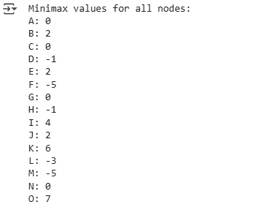
Task 2
Implement Alpha-Beta Pruning on the graph in Task 1.

PROGRAM
# Simple Alpha-Beta Pruning implementation for the given tree

# Terminal values (leaves)
values = {
'H': -1, 'I': 4,
'J': 2, 'K': 6,
'L': -3, 'M': -5,
'N': 0, 'O': 7
}

# Define tree structure as adjacency list
tree = {
'A': ['B', 'C'],
'B': ['D', 'E'],
'C': ['F', 'G'],
'D': ['H', 'I'],
'E': ['J', 'K'],
'F': ['L', 'M'],
'G': ['N', 'O']
}

# Recursive function for Alpha-Beta Pruning
def alpha_beta(node, alpha, beta, isMax):
# If node is a leaf, return its value
if node in values:
return values[node]

if isMax:
maxEval = float('-inf')
for child in tree[node]:
eval = alpha_beta(child, alpha, beta, False)
maxEval = max(maxEval, eval)
alpha = max(alpha, eval)
if beta <= alpha:
print(f"Pruning at node {node} (Max) because beta <= alpha")
break
return maxEval
else:
minEval = float('inf')
for child in tree[node]:
eval = alpha_beta(child, alpha, beta, True)
minEval = min(minEval, eval)
beta = min(beta, eval)
if beta <= alpha:
print(f"Pruning at node {node} (Min) because beta <= alpha")
break
return minEval

# Run Alpha-Beta Pruning from the root
final_value = alpha_beta('A', float('-inf'), float('inf'), True)

print("\nFinal Minimax Value (with Alpha-Beta Pruning) at Root (A):", final_value)

OUTPUT
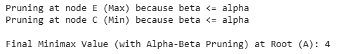

Post Lab Tasks
Task 1
Implement a Tic-Tac-Toe game where the player competes against an AI opponent. The AI will use the Minimax algorithm to determine its optimal moves. Your program should allow players to make their moves and display the current state of the board after each move, including checking for win conditions or draw scenarios.
- Create a 3x3 Game Board to represent the Tic-Tac-Toe board. Initialize it with empty spaces.
- Allow the user to select a position on the board for their move.
- Create a function that allows the AI to evaluate the best move based on the current board state.
- Check after each move to see if a player has won or if the game has ended in a draw.
- Print the board and game messages to indicate the status of the game after each move.

PROGRAM
# Tic-Tac-Toe with Minimax AI

def print_board(board):
print("\nCurrent Board:")
for row in board:
print(" | ".join(row))
print("-" * 9)

def check_winner(board):
# Rows, columns, diagonals
for i in range(3):
if board[i][0] == board[i][1] == board[i][2] != ' ':
return board[i][0]
if board[0][i] == board[1][i] == board[2][i] != ' ':
return board[0][i]
if board[0][0] == board[1][1] == board[2][2] != ' ':
return board[0][0]
if board[0][2] == board[1][1] == board[2][0] != ' ':
return board[0][2]
return None

def is_draw(board):
return all(cell != ' ' for row in board for cell in row)

def minimax(board, is_maximizing):
winner = check_winner(board)
if winner == 'O':
return 1
elif winner == 'X':
return -1
elif is_draw(board):
return 0

if is_maximizing:
best_score = -float('inf')
for i in range(3):
for j in range(3):
if board[i][j] == ' ':
board[i][j] = 'O'
score = minimax(board, False)
board[i][j] = ' '
best_score = max(score, best_score)
return best_score
else:
best_score = float('inf')
for i in range(3):
for j in range(3):
if board[i][j] == ' ':
board[i][j] = 'X'
score = minimax(board, True)
board[i][j] = ' '
best_score = min(score, best_score)
return best_score

def best_move(board):
best_score = -float('inf')
move = None
for i in range(3):
for j in range(3):
if board[i][j] == ' ':
board[i][j] = 'O'
score = minimax(board, False)
board[i][j] = ' '
if score > best_score:
best_score = score
move = (i, j)
return move

def play_game():
board = [[' ' for _ in range(3)] for _ in range(3)]
print("Welcome to Tic-Tac-Toe! You are 'X'. AI is 'O'.")
print_board(board)

while True:
# Player move
try:
row = int(input("Enter row (0-2): "))
col = int(input("Enter col (0-2): "))
except ValueError:
print("Invalid input. Please enter numbers between 0 and 2.")
continue

if 0 <= row <= 2 and 0 <= col <= 2 and board[row][col] == ' ':
board[row][col] = 'X'
else:
print("Invalid move. Try again.")
continue

print_board(board)
if check_winner(board):
print("You win!")
break
if is_draw(board):
print("It's a draw!")
break

# AI move
ai_row, ai_col = best_move(board)
board[ai_row][ai_col] = 'O'
print("AI has made its move:")
print_board(board)

if check_winner(board):
print("AI wins!")
break
if is_draw(board):
print("It's a draw!")
break

# Run the game
play_game()

OUTPUT
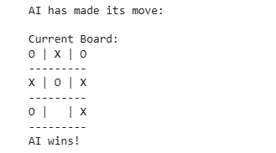
Task 2
Write a function that implements the Alpha-Beta Pruning algorithm to evaluate the game tree. The function should take the current node, depth, alpha, and beta values as parameters. While traversing the tree, keep track of the values that are pruned during the evaluation process and display them in a list. After evaluating the entire tree, return the optimal value at the root node and print it.
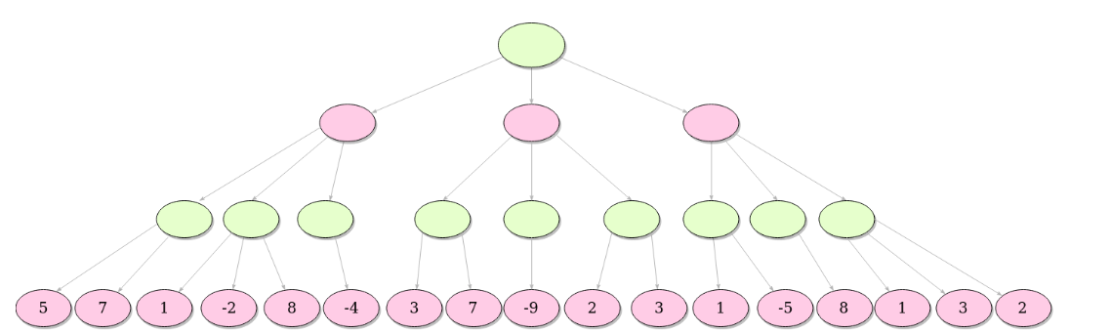
PROGRAM
# Leaf values from left to right
leaf_values = [5, 7, 1, -2, -8, -4, 3, 7, -9, 2, 3, 1, -5, 8, 2]

# Track pruned values
pruned_values = []

def alpha_beta(depth, index, is_maximizing, alpha, beta):
# Base case: leaf node
if depth == 4:
return leaf_values[index]

if is_maximizing:
max_eval = float('-inf')
for i in range(2):
child_index = index * 2 + i
eval = alpha_beta(depth + 1, child_index, False, alpha, beta)
max_eval = max(max_eval, eval)
alpha = max(alpha, eval)
if beta <= alpha:
# Prune remaining children
if i == 0:
pruned_values.append(leaf_values[child_index + 1])
break
return max_eval
else:
min_eval = float('inf')
for i in range(2):
child_index = index * 2 + i
eval = alpha_beta(depth + 1, child_index, True, alpha, beta)
min_eval = min(min_eval, eval)
beta = min(beta, eval)
if beta <= alpha:
# Prune remaining children
if i == 0:
pruned_values.append(leaf_values[child_index + 1])
break
return min_eval

# Run Alpha-Beta Pruning from root
optimal_value = alpha_beta(0, 0, True, float('-inf'), float('inf'))

# Output results
print(f"Optimal value at root node: {optimal_value}")
print(f"Pruned values: {pruned_values}")

OUTPUT
